FOUNDATION: ENDURING FRIENDSHIPS
A Grateful Video from Panama
https://share.icloud.com/photos/0beko0CVVAkEMj4qxocYZclYw
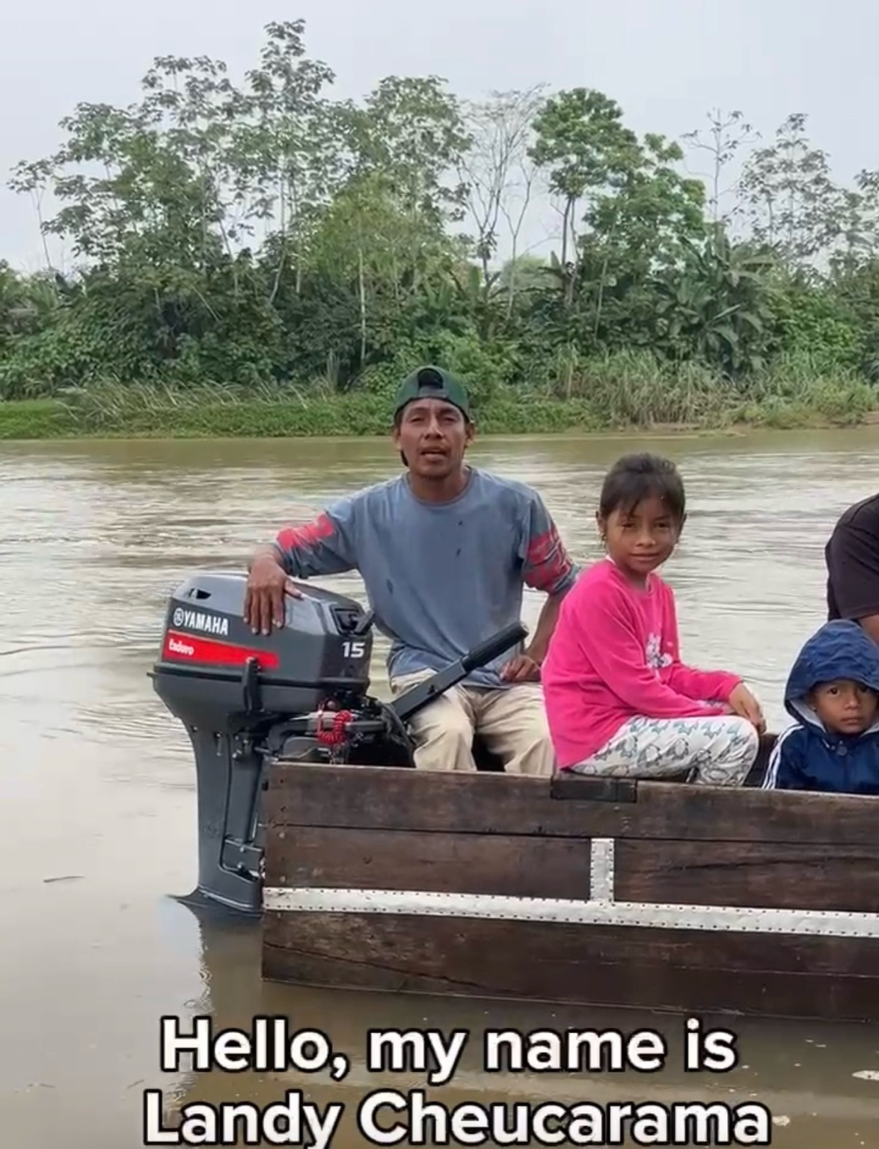

In 2022, the Roswell Rotary Club partnered with the Rotary Club of Panama Nordeste on a Global Grant bringing clean water to remote, underserved communities in Panama. The project delivered lasting impact—and lasting friendships.
Landy Cheucarama, a local village leader, worked tirelessly to help implement the grant. Recently, we learned his region had suffered devastating crop losses, and that the boat motor his family relies on for daily life had failed.
With few roads, river travel is essential, Roswell Rotarians acted quickly. An ad-hoc effort raised funds for a new motor in just days. Rotarian Langdon Hollingsworth traveled to Panama and personally delivered it—five hours away by rented truck.
In the accompanying video, Landy shares his gratitude. This is Rotary fellowship at work: relationships that endure, and service that continues long after a grant is complete.

